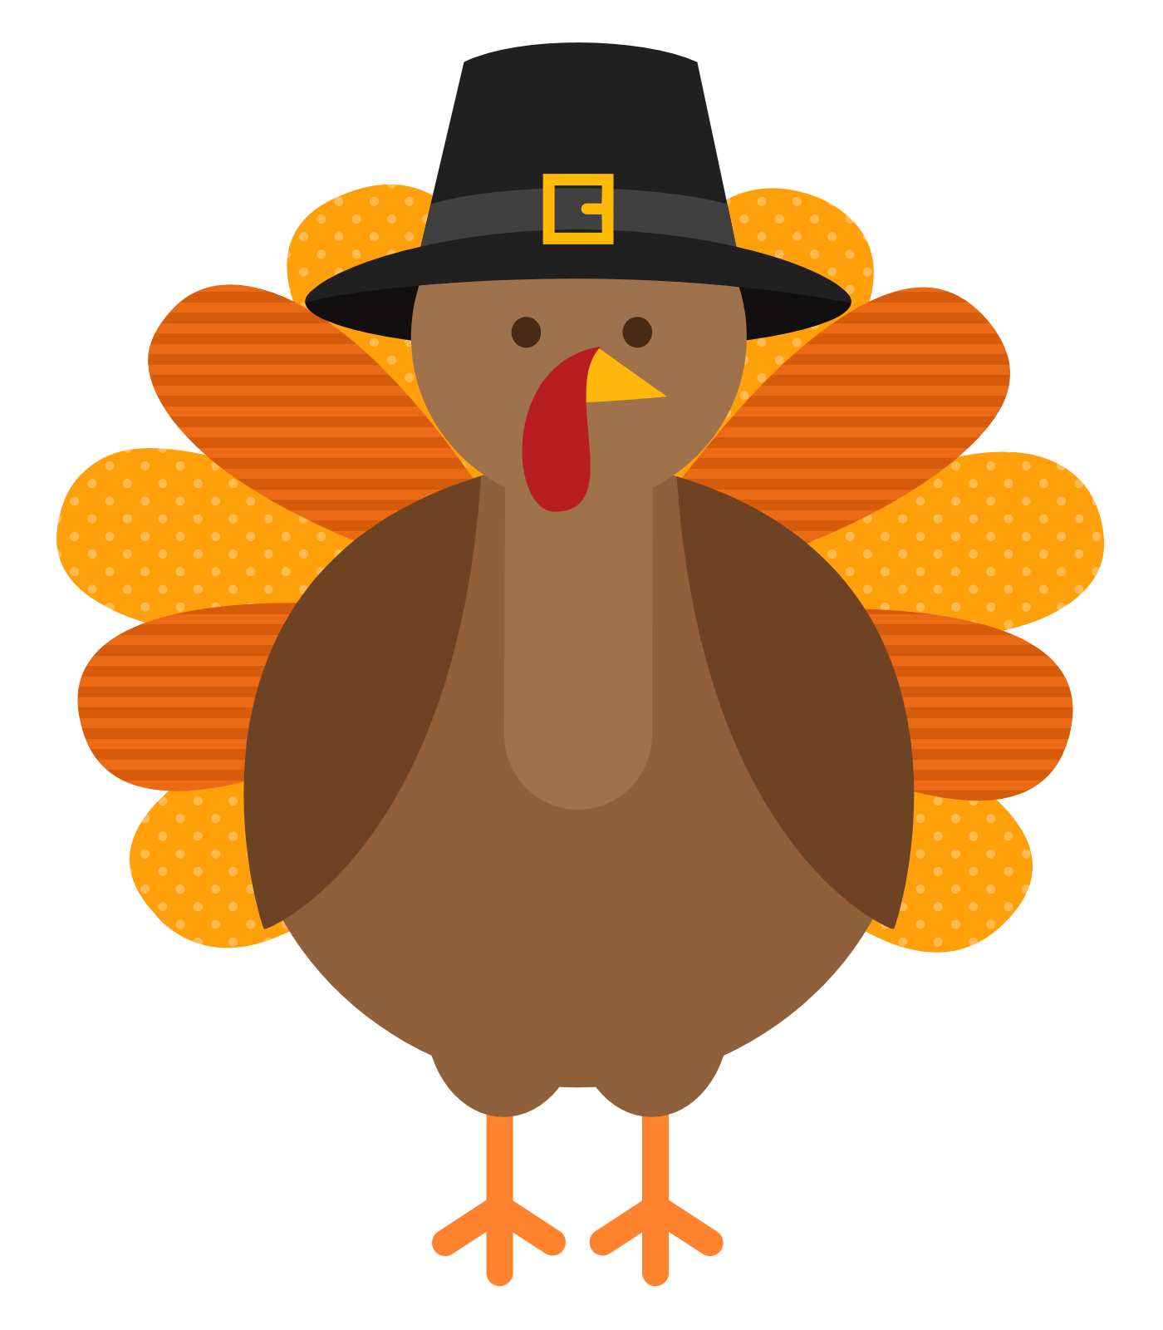

THANKSGIVING

HAPPY

APPETIZER OF THE DAY DESSERT OF THE DAY

CAULIFLOWER CRUST BRUSCHETTA…$8.99 XANGO.......$9.99 PUMPKIN PIE.....$4.50

FRIED CALAMARI…………$9.99 APPLE PIE....$4.50 OR PECAN PIE..$4.50

SOUPS OF THE DAY

CREAM OF TURKEY WITH RICE, MINNESTRONE OR BUTTERNUT SQUASH

A. ROAST TURKEY………….…………………..........................……$16.99

CHOICE OF WHITE AND DARK MEAT MIX OR ALL WHITE MEAT SERVED WITH STUFFING,

CRANBERRY SAUCE, AND TWO VEGETABLES

1. HAM STEAK…………………………………….…..........................$14.99 TOPPED WITH FRUIT SAUCE AND SERVED WITH TWO VEGETABLES
2. THANKSGIVING SEAFOOD SCAMPI…………............................$25.99 SHRIMP, SCALLOPS, CRABMEAT, LITTLE NECK CLAMS AND BROCCOLI FLORETS IN A GARLIC LEMON SCAMPI SAUCE SERVED OVER ANGEL HAIR
3. PASTA FEAST............…………………......…..........................……$18.99

PENNE PASTA, GNOCCHI, SPINACH RAVIOLI, CHEESE RAVIOLI AND CHEESE MANICOTTI,

TOPPED WITH SHRIMP AND FRESH SPINACH ALFREDO SAUCE

1. BROILED SALMON OSCAR..................……..…..…............……..$21.99

TOPPED WITH ASPARAGUS, CRABMEAT AND HOLLINDAISE SAUCE, SERVED WITH TWO

VEGETABLES

1. LAMB CHOPS………….…………................………………............$20.99

OVER GARLIC MASHED POTATOES TOPPED WITH FRIED BERMUDA ONIONS AND SERVED

WITH TWO VEGETABLES

1. BLACK OLIVE PRIME RIB ………………………..........................$25.99 SERVED WITH A FRIED LOBSTER TAIL AND TWO VEGETABLES

VEGETABLE OF THE DAY

MASHED POTATOES, BAKED POTATO, FRENCH FRIES, COLE SLAW, APPLE SAUCE, PICKLED BEETS, COTTAGE CHEESE, STEAMED RICE, BROCCOLI, CANDIED SWEET POTATOES, ASPARAGUS, OR SWEET CUT CORN

